INTRODUCTION: -

Our language is vague, and the thinking confused -> this book would encourage precision

* Logic has become a broad subject -> focus on correct REASONING (a.k.a THEORY OF LOGICAL INFERENCE/ PROOF/ DEDUCTION)

-> INFERENCE is applied in every systematic Knowledge (looking for usefulness and accuracy in predictions)

* A real THEORY OF INFERENCE (ToI) has been developed only in the last century, even though mathematicians and philosophers were making a number of INFERENCES -> the problem is that until Frege virtually nobody

ever linked logic and mathematics and explicitly

formulated a ToI (a partial exception is Leibniz)

-> a ToI founds application in every human

deliberation, as correct REASONING ‘’is

valid by virtue of its logical form’’

* Arguments are expressed in ordinary language and a few SYMBOLS, but the logical structure is not self-evident

Through these, it is easier to establish rules of INFERENCE

* But logical precision comes even from the method

of defining a concept starting from other ones;

to eliminate vagueness, mathematics and sciences have a few concepts have been put as the foundation

over which every other is built -> correct definitions depend on logical form

(just as INFERENCES, even if the theories

related to these two have slight differences)

* Set Theory: -> basic discipline of mathematics (almost every entity might be

considered particular sets, and only by custom Set Theory refers

to a general theory of classes)

-> even operations on sets correspond to arithmetical operations

-> every branch of maths and every scientific theory might be

axiomatized thanks to the Set Theory

* Much has been written about the structure of scientific theories, but not much about the particular structure of individual theories => Axiomatization of a theory within ST grants an exact and explicit structure, after which really structural questions might find answer

In general:

Still in a broader sense, it includes the GENERAL THEORY OF SETS

In a broader sense, it includes the THEORY OF DEFINITION

LOGIC is the THEORY OF DEDUCTIVE INFERENCE

These two provide the basis for the AXIOMATIC METHOD

**CHAPTER 1 – THE SENTENTIAL CONNECTIVES:**

Aim at developing a precise vocabulary, apt for systematic knowledge

The first thing is to fix SENTENTIAL CONNECTIVES (‘not’, ’and’, ’or’, ’if… then’, etc.), whose usage comes from that in everyday context, even if there could be divergences

* 1. **NEGATION AND CONJUNCTION:**

We deny the TRUTH of a SENTENCE by asserting its NEGATION   
(e.g. negating ‘Sugar causes tooth decay means that ‘Sugar does not cause tooth decay’)

* we simply use the sign ‘–‘ regardless of whether the SENTENCE is simple or compound (i.e. –P)
* *The NEGATION of a true SENTENCE is false and the NEGATION of a false SENTENCE is true*

1. We use ‘and’ (sign ‘&’) to bound two SENTENCES to make the CONJUCTION of the two
2. The CONJUNCTION of any SENTENCE P with another one Q IS P & Q
3. *The CONJUNCTION of two SENTENCES is true if and only if both are true*
4. ‘but’ is also symbolized by ‘&’

These rules make ‘–‘ and ‘&’ TRUTH-FUNCTIONAL = *TRUTH or falsity of the NEGATION or the CONJUNCTION is a function just of the SENTENCES to which it refers ->* any non-truth-functional analysis is vague

Still, the loss of linguistic subtlety is a feature of any science

* 1. **DISJUNCTION**:

‘or’ is used to get the DISJUNCTION of two sentences

* ‘or’ can be non-exclusive/ INCLUSIVE (at least one of the SENTENCES is true) or EXCLUSIVE (one is true and the other is false), but in the end the INCLUSIVE sense comprises even the other one
* The sign ‘∨’ is used for the DISJUNCTION, and with two SENTENCES it is put in the form P ∨ Q
* The DISJUNCTION is true if and only if at least one of the SENTENCES is true
  1. **IMPLICATION**:

CONDITIONAL SENTENCES: we use ‘if… then’ to get from two SENTENCES -> a CONDITIONAL SENTENCE is just as P ⇒ Q

-> ⇒ is the sign of IMPLICATION

-> *A CONDITIONAL SENTENCE is false if the antecedent is true and the consequent is false; otherwise it is true\**

*-> P* ⇒ Q and Q ⇒ P are equivalent, except from minor grammatical change if appropriate

* 1.6 TRUTH TABLES AND TAUTOLOGIES: -> our TRUTH-FUNCTIONAL rules may be summarized

through tables that tell us in which situations certain

SENTENCES are true or false

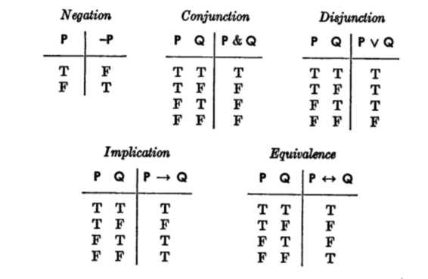

* Now we can compute the truth or falsity of compound sentences like:

((N ∨ G) & –N) ⇒ (G ⇒ N) considering N as true and G as false

T F F F T

T T

F

T

* A SENTENCE is ATOMIC if it contains no SENTENTIAL CONNECTIVES (e.g. ‘’Mr. Knightley loved Emma’’ is ATOMIC, while ‘’Emma did not love F. Churchill’’ is not)
* A TAUTOLOGY is a compound SENTENCE true independently of the TRUTH-VALUES of its components (that are ultimately ATOMIC SENTENCES)

E.g. P ∨ –P is a TAUTOLOGY

* We could also use derived truth tables to compute the TRUTH-VALUE of a compound SENTENCE
* If there are n ATOMIC SENTENCES in a compound one, the latter has 2n TRUTH-VALUES
* A SENTENCE is a TAUTOLOGY if and only if the result of replacing any of its component ATOMIC SENTENCES by other ATOMIC SENTENCS always gives out a true SENTENCE, regardless of its components being the same SENTENCE or not (e.g. P ∨ Q ⇒ P can be a TAUTOLOGY if we let P be ‘it is either raining or not’ and Q ‘it is hot’)
* NB: a non-tautological statement could become a TAUTOLOGY by operating certain substitution (i.e. replacing compound SENTENCS for ATOMIC ones or substituting the same SENTENCE for distinct ones)

CHAPTER 3 – SYMBOLIZING EVERYDAY LANGUAGE:

* 3.1 GRAMMAR AND LOGIC: -> the developed notation is not enough (even though we do not

want to represent every aspect of ordinary language through

symbols)

-> our goal is to express systematic facts, and for this we use

TERMS, PREDICATES and QUANTIFIERS, in addition to connectives

and parentheses

* 3.2 TERMS: -> here we use VARIABLES (not differently from mathematics) instead of pronouns

and common nouns

-> proper names are represented by lower-case letters

-> since definite descriptions work like proper names, we use other lower-case

letters standing for them (in general these letters are like CONSTANTS)

E.g. ‘Newton is the greatest scientist of all times’ can be symbolized as ‘a=b’

* *A TERM is an expression which either names or describes some object, or results in a name or description of an object when the VARIABLES in the expression are replaced by names and description.*
* E.g. ‘x’ is a TERM, as replacing it with 3, we get an expression defining that number
* 3.3 PREDICATES: -> capital letters are used in place of PREDICATES (e.g. ‘Everything is either red

or not’ is ‘For every x, Rx ∨ –Rx’)

-> there are no particular SYMBOLS for adverbs and such, while common nouns

are symbolized through VARIABLES and PREDICATES

-> ONE-PLACE PREDICATES refer to features of a single TERM (e.g. ‘Emma was

very gay’ could be translated in ‘Ge’)

-> TWO-PLACE PREDICATES consider comparisons and direct connections

between two TERMS (e.g. ‘Mr. Knightley is older than Emma’ is ‘Oke’)

-> there are also THREE- and FOUR-PLACE PREDICATES, concerning

betweenness and equidistance respectively (and through these Euclidean

geometry could be axiomatized)

-> a COMPOUND PREDICATE conjuncts two different PREDICATES (and we could

also use another PREDICATE that merges the previous ones)

E.g. Emma was very gay and beautiful could be Ge & Be or We, with the

choice falling on one or the other depending on convenience

* 3.4 QUANTIFIERS: -> we prefix two different kinds of expressions to our formulas

EXISTENTIAL QUANTIFIERS (there is at least one x such that), written (∃x)

E.g. ‘x > 0’ is ‘(∃x)(x > 0)’

UNIVERSAL QUANTIFIERS (for every x), written ‘(x)’

E.g. ‘Everyone is a miser’ is ‘(x)(x is a miser)’

-> we are able to symbolize SENTENCES like ‘Every man is an animal’ in

‘(x)(Mx ⇒ Ax)’ and ‘Some freshmen are intelligent’ in ‘(∃x)(Fx & Ix)’**

* 3.5 BOUND AND FREE VARIABLES: -> a VARIABLE is either controlled by a QUANTIFIER or it is

not

* An ATOMIC FORMULA is a PREDICATE followed by an appropriate number of TERMS (e.g. x is blue is an ATOMIC FORMULA)
* FORMULAS are defined this way:

1. Every ATOMIC FORMULA is a FORMULA
2. If S is a FORMULA, –S is a FORMULA
3. If R and S are FORMULAS, R & S, R ∨ S, R ⇒ S and such are FORMULAS
4. If R is a FORMULA and v is any VARIABLE, then (v)(R) and (∃v)(R) are FORMULAS
5. No expression is a FORMULA unless its being so follows from these rules

* This is not perfectly precise as a definition, but it will serve our purpose
* A FORMULA doesn’t have to be meaningful, just to follow syntactical rules
* *The SCOPE of a QUANTIFIER occurring in a FORMULA is the QUANTIFIER together with the smallest FORMULA following the QUANTIFIER*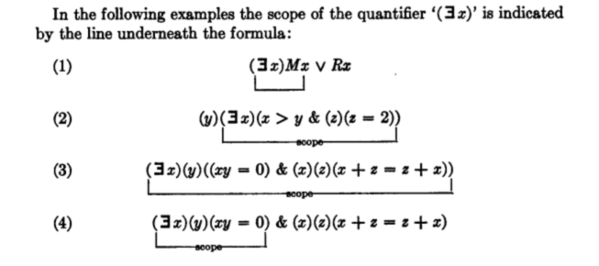

NB.: the parentheses are a big help in identifying the smallest formula

following the QUANTIFIER

* *An occurrence of a VARIABLE in a FORMULA is BOUND if and only if this occurrence is within the SCOPE of a QUANTIFIER using this VARIABLE*, while *it is FREE if this occurrence is not bound*
* It follows that *a VARIABLE is a FREE VARIABLE in a FORMULA of at least one occurrence of the VARIABLE is free*, while *it is BOUND if at least one is BOUND* (a particular VARIABLE may be both FREE and BOUND in a FORMULA, even if the single occurrence cannot)
* E.g. in y > 0 ∨ (∃y)(y < 0), ‘y’ is both FREE and BOUND; its first occurrence is FREE, and the other two are BOUND
* *A SENTENCE is a FORMULA which has no FREE VARIABLES*, and thus is either true or false
* 3.6 A FINAL EXAMPLE: -> we have to consider more complicated SENTENCES

E.g. ‘If one instant of time is after a second, then there is an instant

of time after the second and before the first’

* to translate we first need to introduce VARIABLES, and then replace

the descriptive phrase ‘instant of time’ with a PREDICATE such as in

‘If x is an instant of time, y is an instant of time, and x is after y, then

there is a z such that z is an instant of time, z is after y, and z is

before y’.

* at this point we obtain Tx & Ty & Azy ⇒ (∃z)(Tz & Azy & Bzx), which has two FREE VARIABLES and thus is not a SENTENCE which could be either true or false (while the sentence we began with is clearly a SENTENCE)
* in our final step we write (x)(y)[Tx & Ty & Azy ⇒ (∃z)(Tz & Azy & Bzx)]